NAT Check (Instructor Version)

**Instructor Note**: Red font color or Gray highlights indicate text that appears in the instructor copy only.

1. Objective

Configure, verify and analyze static NAT, dynamic NAT and NAT with overloading.

Instructor Note: This activity can be completed individually or in small or large groups.

1. Scenario

Network address translation is not currently included in your company’s network design. It has been decided to configure some devices to use NAT services for connecting to the mail server.

Before deploying NAT live on the network, you prototype it using a network simulation program.

1. Resources

* Packet Tracer software
* Word processing or presentation software

1. Directions
   1. Create a very small network topology using Packet Tracer, including, at minimum:
      1. Two 1941 routers, interconnected
      2. Two LAN switches, one per router
      3. One mail server, connected to the LAN on one router
      4. One PC or laptop, connected the LAN on the other router
   2. Address the topology.
      1. Use private addressing for all networks, hosts, and device.
      2. DHCP addressing of the PC or laptop is optional.
      3. Static addressing of the mail server is mandatory.
   3. Configure a routing protocol for the network.
   4. Validate full network connectivity without NAT services.
      1. Ping from one end of the topology and back to ensure the network is functioning fully.
      2. Troubleshoot and correct any problems preventing full network functionality.
   5. Configure NAT services on either router from the host PC or laptop to the mail server
   6. Produce output validating NAT operations on the simulated network.
      1. Use the **show ip nat statistics**, **show access-lists**, and **show ip nat translations** commands to gather information about NAT’s operation on the router
      2. Copy and paste or save screenshots of the topology and output information to a word processing or presentation document.
   7. Explain the NAT design and output to another group or to the class.
2. Suggested Activity Example (student designs will vary):
3. NAT Topology Diagram

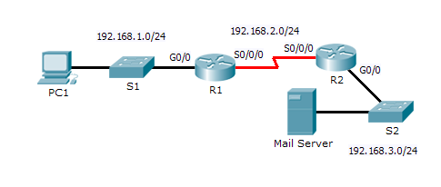

|  |
| --- |
| R2# **show ip nat translations**  Pro Inside global Inside local Outside local Outside global  icmp 192.168.1.1:2 192.168.1.2:2 192.168.3.2:2 192.168.3.2:2 |
| R2# **show ip nat statistics**  Total translations: 1 (0 static, 1 dynamic, 1 extended)  Outside Interfaces: GigabitEthernet0/0  Inside Interfaces: Serial0/0/0  Hits: 2 Misses: 5  Expired translations: 2  Dynamic mappings:  -- Inside Source  access-list 1 pool R1 refCount 1  pool R1: netmask 255.255.255.0  start 192.168.1.1 end 192.168.1.254  type generic, total addresses 254 , allocated 1 (0%), misses 0 |
| R2# **show access-lists**  Standard IP access list 1  permit 192.168.1.0 0.0.0.255 (6 match(es)) |

1. Identify elements of the model that map to IT-related content:
2. NAT
   1. Configuration
   2. Operation
   3. Troubleshooting